HandlingTech
Automations-Systeme

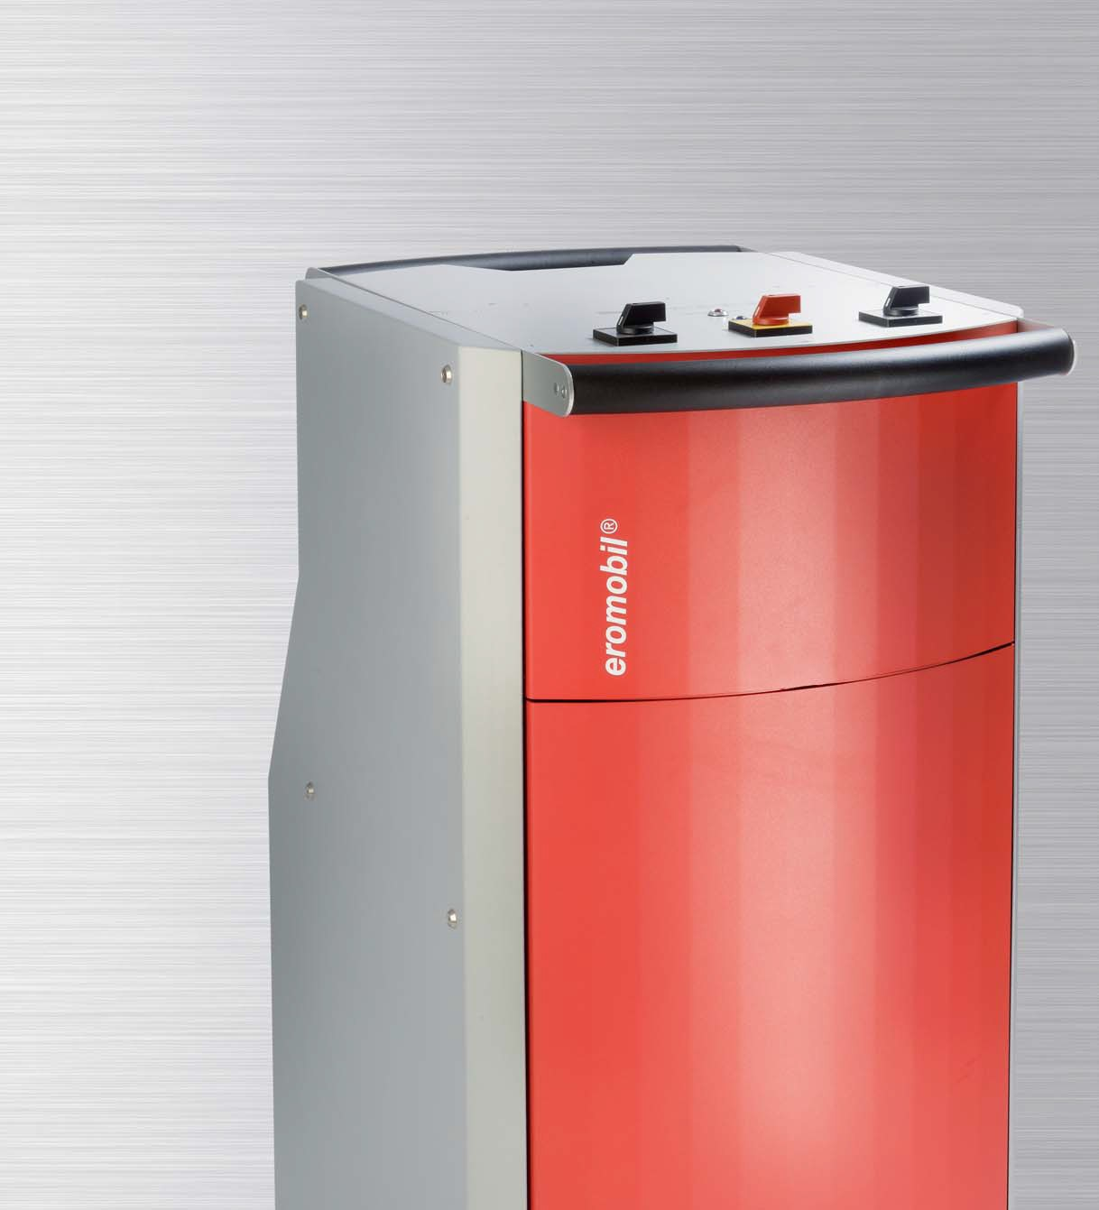
THE EROMOBIL® -
FIRST AID FOR TOOL BREAKAGE

eromobil® Models
Operating principle Optional accessories Radial erosion unit Example applications

MADE IN GERMANY

eromobil® | The solution for tool breakage
Models
Operating principle Optional accessories Static radial erosion unit Example applications
MADE IN GERMANY
eromobil®
Models
Operating principle Optional accessories Static radial erosion unit Example applications

HandlingTech
Automations-Systeme

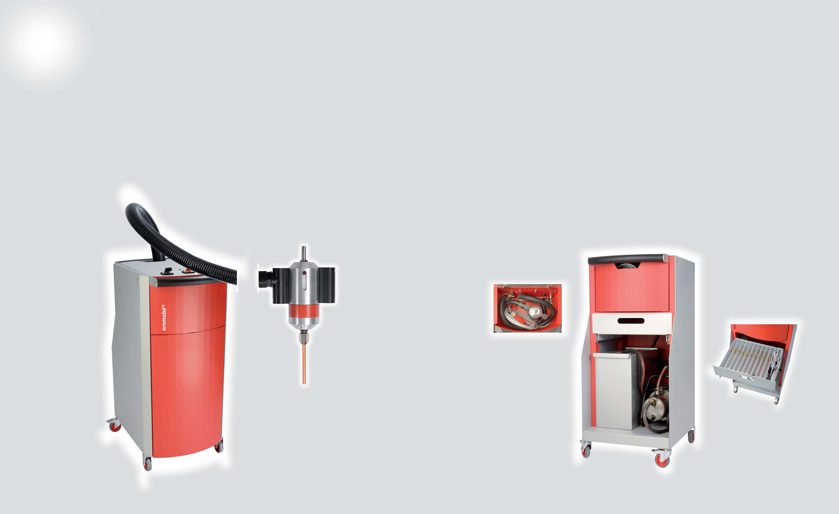
THE EROMOBIL® THE MODELS

The solution for tool breakage

Compact, functional, practical
Since it was invented in 1972, the eromobil® has been the most effective solution for tool breakage.
Its design makes the eromobil® compact and functional. The intelligent configuration incorporates all of the components in a clearly-arranged and space-saving manner, and it is both easy and comfortable to use.
The eromobil® was awarded the Plus X Award for its operator comfort, design, functionality and high quality.
Interruptions to production as a result of tool breakage can be remedied immediately with the aid of the
eromobil® . Broken-off thread taps, spiral bits and much more besides can be eroded in minutes.
eromobil ® er230s-ND

For threads from M 2 to approx. M 20.
220/230 V AC; 3.6 kVA; 16 A; 50 Hz.

Standard scope of supply:
eromobil ® er400t-ND

For tools from M 2 to M 40.
Optimally suited for deep drill holes and carbide tools.
380/400 V DC; 6.0 kVA; 16 A; 50 Hz.
Other operating voltages are available.

This avoids damage to workpieces, as well as the associated costs. Generator in trolley, oscillating head, supply hose, earth cable, coolant pump, coolant tank, 1x open-ended spanner WAF19 and WAF24 respectively,
10 anti-splash bags and operating instructions.
Supply hose 2 m from the generator to the oscillating head (sizes up to 7.5 m available)
Oscillating head with ergonomic handles and LED indicator light, with 12 mm cylindrical shank socket

Storage tray for oscillating head, supply hose and earth cable

Generator in a robust compact housing with ergonomic handles, allowing it to be lifted out and transported with ease.

Tool drawer with internal compartments for electrodes, collet chucks, open-ended spanners, anti-splash bags and accessories; pulls out on
smooth-running profile rails

Open cover housing compartment with oscillating head and supply hose

Trolley with storage space for coolant pump and tank, with smooth-running lockable castors

Coolant tank with two chambers for supply and return, with practical carrying handles
Coolant pump for effective flushing with approx. 3.4 bar pressure incl. 2 m intake hose with foot valve, and a 2 m pressure hose with quick- release coupling (hoses up
to 5 m available)

Front view Back view

THE OPERATING PRINCIPLE OPTIONAL ACCESSORIES

Erosion of broken-off thread taps, spiral bits, etc. in just minutes.

The hollow copper electrode is clamped in the oscillating head. This is smaller in diameter than the broken-off tool. During the erosion process, the core of the broken-off tool is worn away. This releases the cutting edges and allows them to be easily removed. The electrode does not come into contact with the workpiece, thus ensuring that the thread remains undamaged. The company's standard choice of drilling emulsion is used for the coolant.

1 Magnetic stand

2 Deep hole inspection light with plug-transformer

The right hollow electrode for every application case

Electrodes of Ø 12 mm and up have a clamping adapter of Ø 10 mm, so the largest collet chuck is always Ø 10 mm. Electrodes can be supplied up to Ø 30 mm and 1000 mm in length.
Thread (metric mm) | Electrode size | Collet chuck size
ø 2 -2,5 | ø 1.0 mm | ø 1.0 mm
ø 3 | ø 1.5 mm | ø 1.5 mm
ø 4 | ø 2.0 mm | ø 2.0 mm
ø 5 | ø 2.5 mm | ø 2.5 mm
ø 6 | ø 3.0 mm | ø 3.0 mm
ø 7 | ø 3.5 mm | ø 3.5 mm
ø 8 | ø 4.0 mm | ø 4.0 mm
ø 9 | ø 4.5 mm | ø 4.5 mm
ø 10 | ø 5.0 mm | ø 5.0 mm
ø 12 | ø 6.0 mm | ø 6.0 mm
ø 14 | ø 7.0 mm | ø 7.0 mm
ø 16 | ø 8.0 mm | ø 8.0 mm
ø 18 | ø 10.0 mm | ø 10.0 mm
ø 20 | ø 12.0 mm | ø 10.0 mm

Special hollow electrodes made from tungsten/

3 Punches

4 Oscillating head socket MK-2 and MK-3

copper are used to erode solid carbide tools.
These are available from Ø 1.0 mm to 20.0 mm.

NEW!
Square-section copper hollow electrodes from 3 x 3 mm to 30 x 30 mm are also available.

www.handlingtech.de/eromobil
- Magnetic stand: For erosion on large magnetisable workpieces. With holding bracket and special flange for receiving the oscillating head. Carriage moveable, upper section sliding and pivoting.

- Deep hole inspection light: With bulb holder ø 5 mm. Available in lengths of 35 mm or 100 mm to illuminate the holes after erosion. Also comes with a 230 V plug-in transformer to enable use for any inspection task.

- Oscillating head socket: MK-2/MK-3, right in the spindle sleeve.

- Punches: For easy removal of the tool residues after erosion. Available as a set in diameters of 2.0 / 3.0 / 4.0 / 5.0 / 6.0 mm.

- A range of chuck keys will also be available soon for processing with square-section copper hollow electrodes, for the removal of residues after the erosion process.
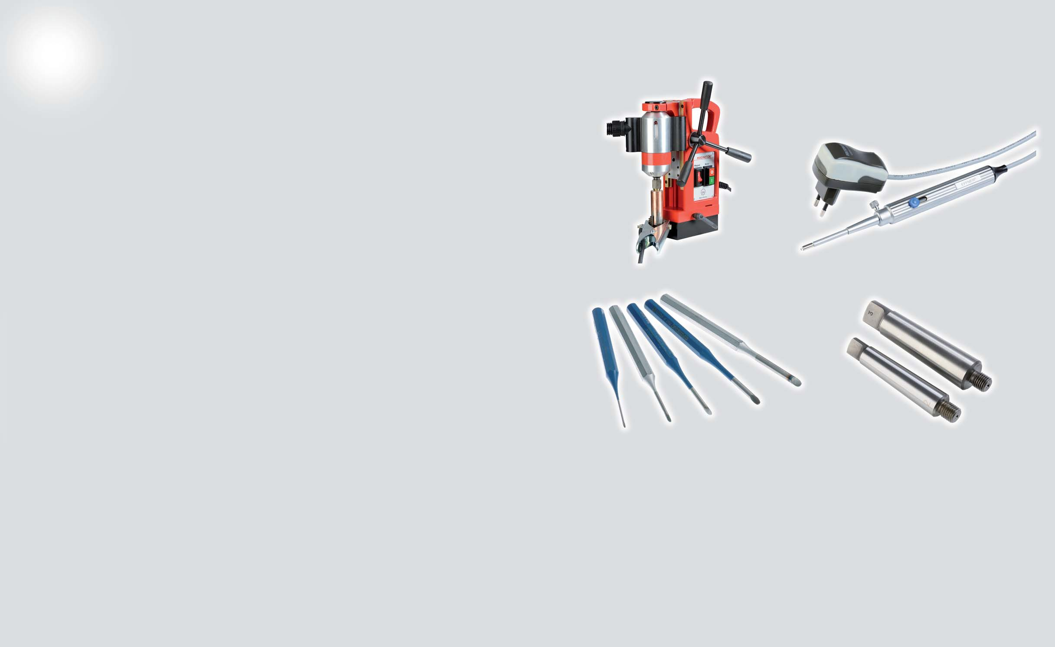
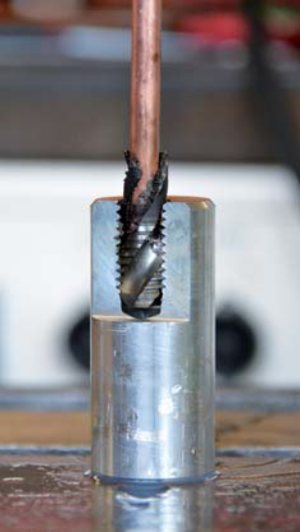
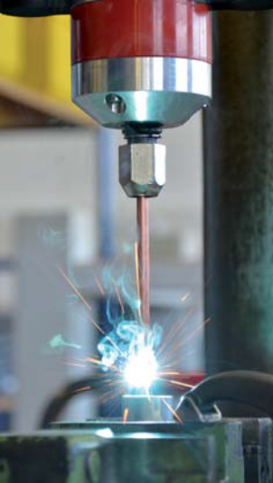
5

STATIC RADIAL EROSION UNIT EXAMPLE APPLICATIONS

Characteristics Technical data

- Quick to use, as no conversion of the erosion device is necessary
- Flexible positioning of the erosion head
- Erosion of large workpieces and slanting drill holes possible
- Wastage and defects during production are avoided, time and cost savings are achieved
- For processing small (front table) and larger (rear table) workpieces
- Radial frame with moveable X and Z-axis
- Z-axis digital display, can be referenced
- MK-3 spindle sleeve
- Z-axis can be turned 360°
- 240 V /50 Hz connection
- Coolant tank pulls out separately
- With two work tables with T-groove plates: Height of front table: 942 mm
Height of rear table: 130 mm
- Overall size (H x W x D): 2016 x 910 x 1365 mm

Erosion of large workpieces on the rear table of the static radial erosion unit

Erosion with automatic feed mechanism

Erosion of a camshaft. Instead of the drill bit, the oscillating head of the erosion device is clamped in the machine

Variant 1
Static radial erosion unit with manual feed

Variant 2
Static radial erosion unit with automatic feed
  - Permanently integrated eromobil® generator
  - Pull-out drawer for the generator
  - Including electrode drawer
  - Digital display can be freely programmed and referenced

www.handlingtech.de/eromobil

Horizontal erosion on a CNC lathe.
The feed rate is regulated manually with the hand wheel

Erosion at any angle position or of large components

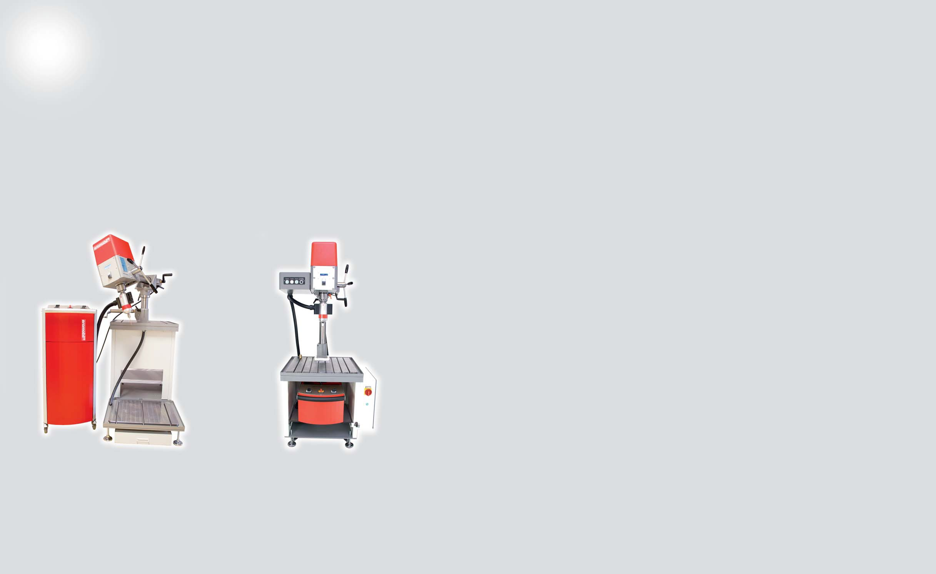
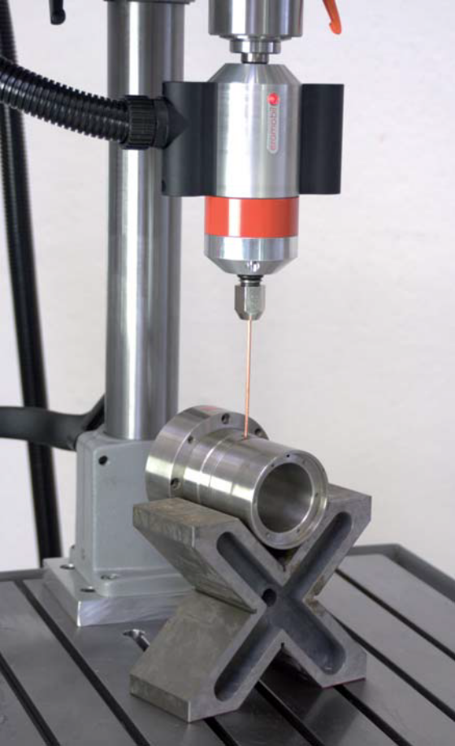
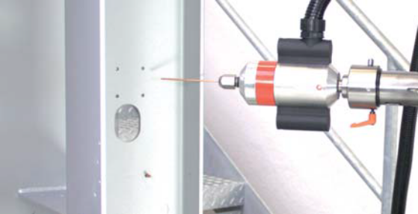
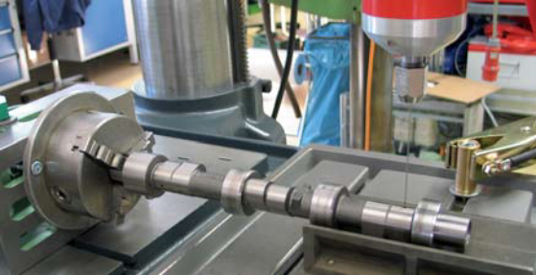
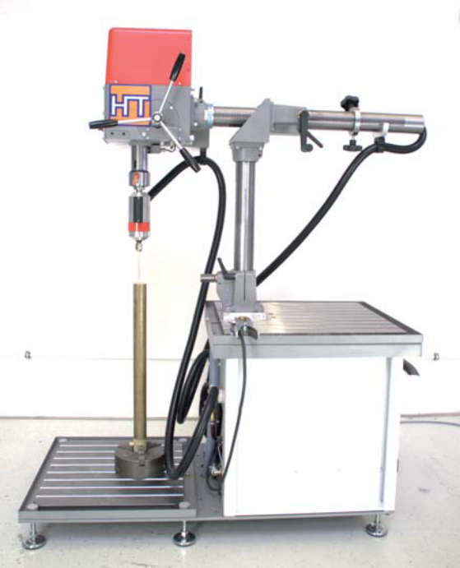
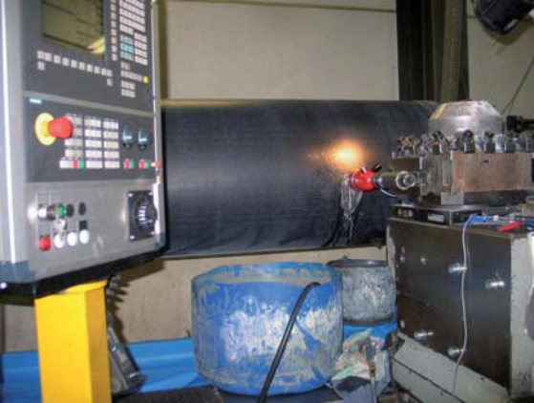
6 7

MADE IN GERMANY

The most effective solution for tool breakage - www.handlingtech.de/eromobil

Your Agent for Australia and New Zealand:

31 Greenfields Circle
Hocking, WA, 6065, Australia
+614 (04) 20 226 880
sales@asap-power.com.au
www.asap-power.com.au

HandlingTech
3rd Edition 05/2015
Automations-Systeme

HandlingTech Automations-Systeme GmbH Gewerbestr. 7
71144 Steinenbronn/Germany
Tel: +49 (0)7157/ 9 8919-60
Fax: +49 (0)7157/ 9 8919-33
eromobil@handlingtech.de
www.handlingtech.de/eromobil

